*Filling Problems*

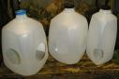Using only two containers which hold 5litres and 3litres how could you measure out 2litres of water?

What other amounts could be measured out?

Show your reasoning clearly.

Mike the miner has a large empty storage container and two measuring cups – 10kg and 3kg.

How can he measure out exactly 22kg of gold dust?

Can he do it in more than way?

Mick the Mechanic needs to measure 3 litres of oil. He has two cans: one holds 4 litres and the other 5 litres.

Can you help him?

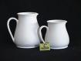What quantities of water may be measured using a 7 litre container and a 2 litre container?

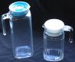How can you measure 7 litres of water with a 3 litre and an 8 litre container?

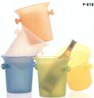You have two buckets which hold 5 pints and 7 pints. There is a tap with running water.

How do you use these two buckets to get 6 pints?